Assignment: 2

Problem Statement: Create MFA for authentication. Steps to create MFA:-

Step 1: Click on the name of the profile (i.e. top right of the screen).

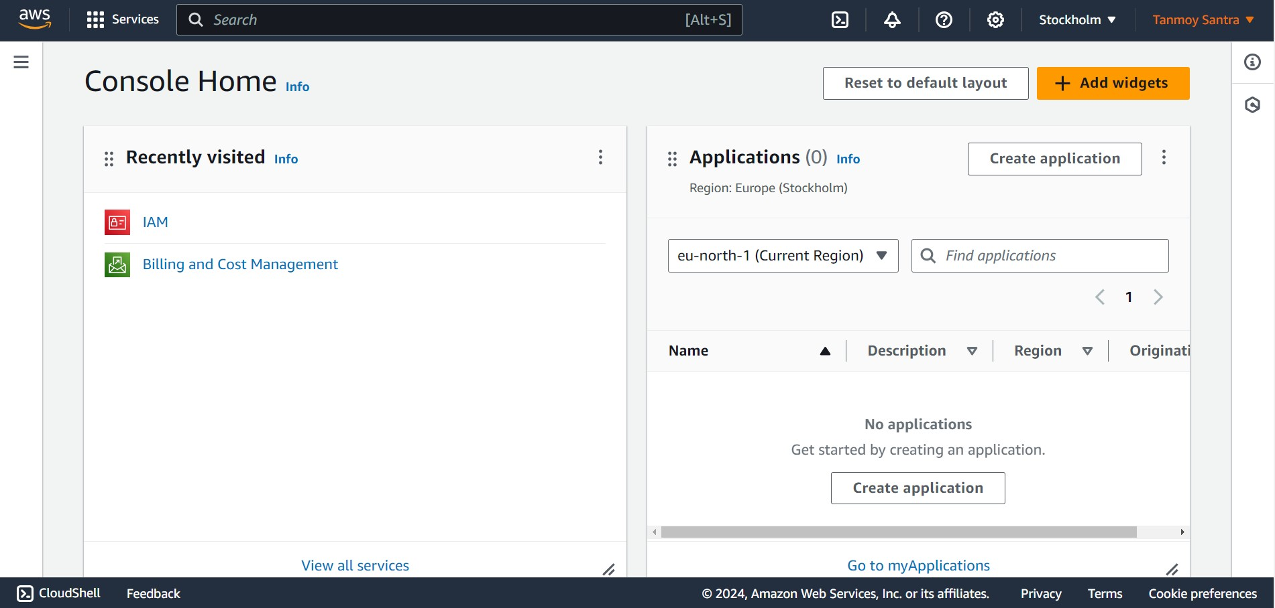

Step 2: Select “Security credentials” option.

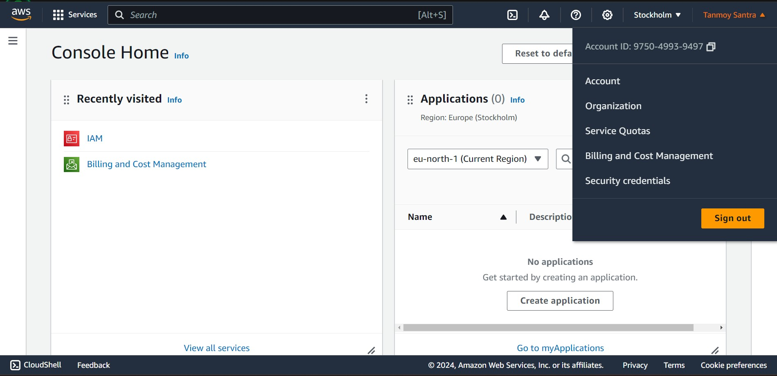

Step 3: Select “Assign MFA” option.

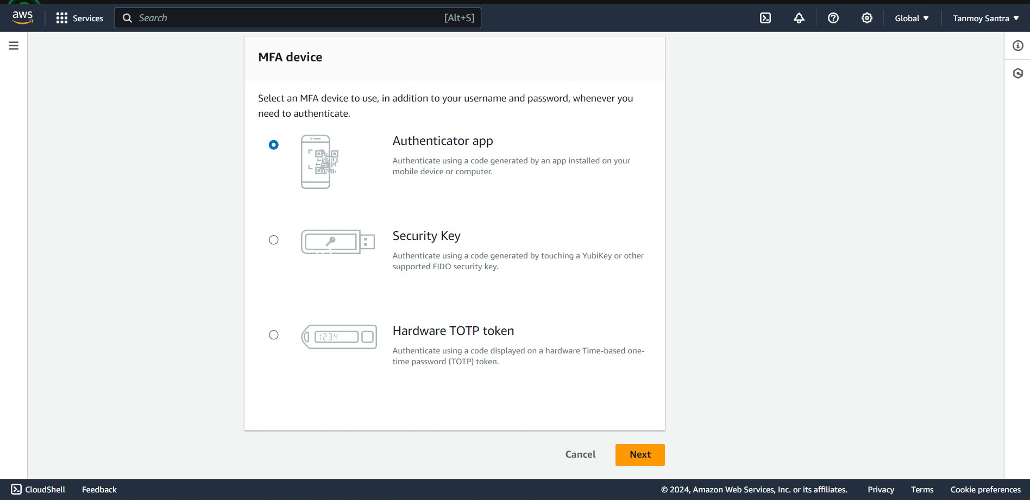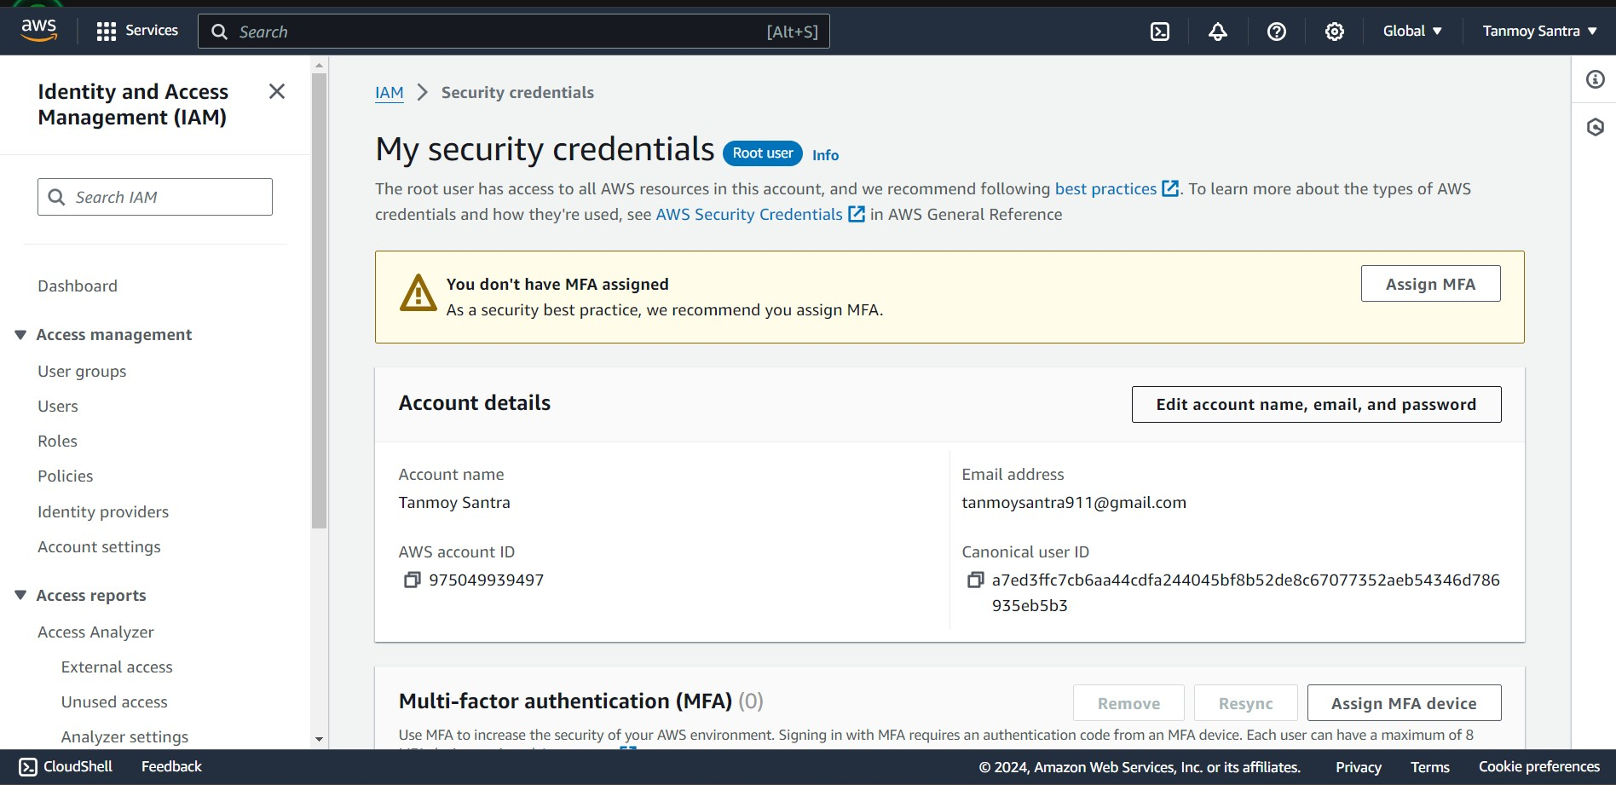

Step 4: Give device name (i.e. ‘Tanmoy_GalaxyA10’ in my case) & Select “Authenticator app” option then “Next”.

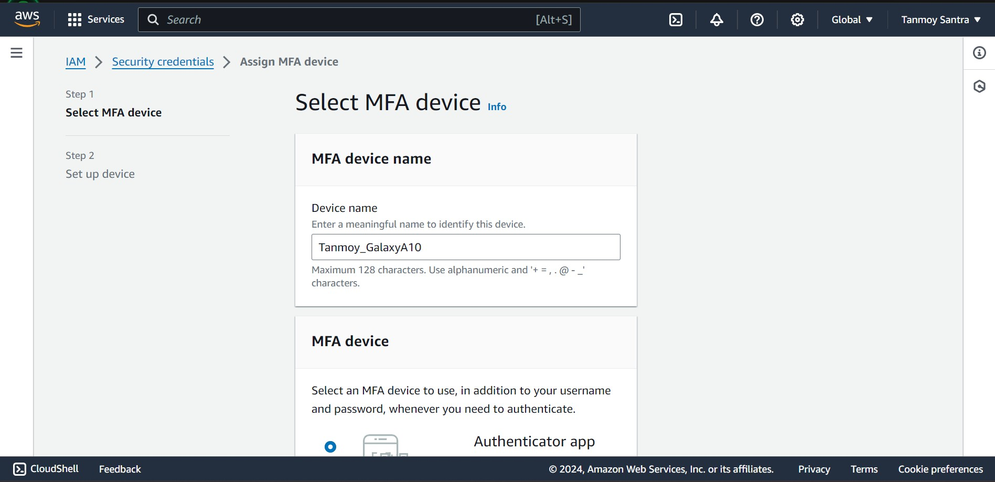

Step 5: Scan the QR code from the mobile phone using “Google Authenticator” app & provide

Step 5: Scan the QR code from the mobile phone using “Google Authenticator” app & provide the MFA code two time from the app then press “Add MFA”.

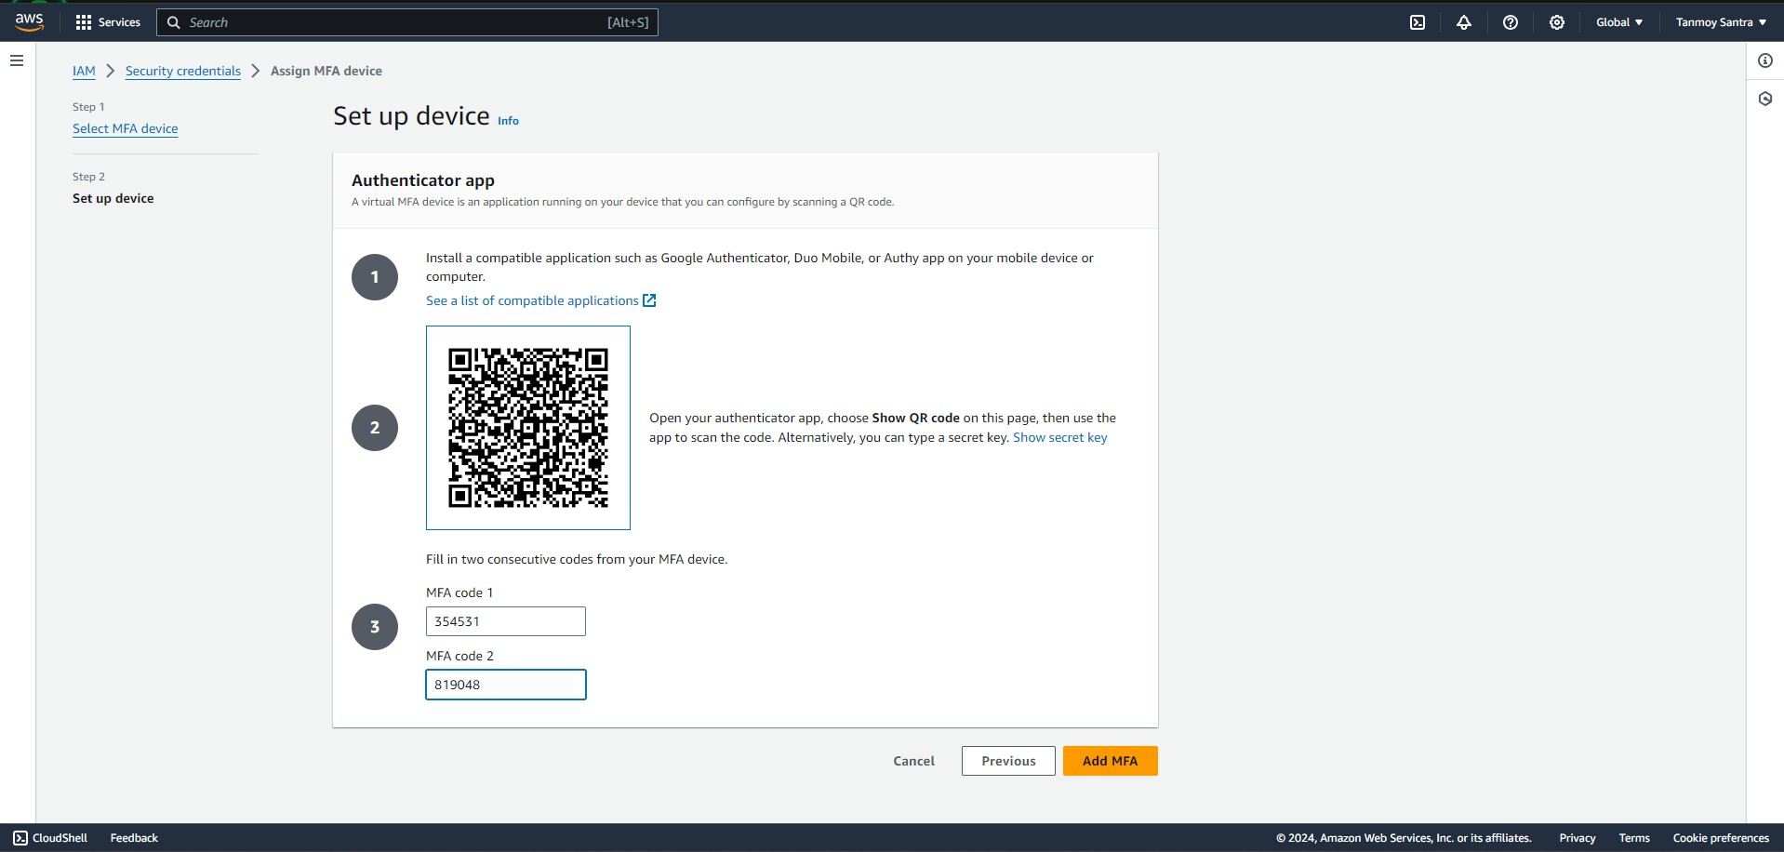

Step 6: MFA created successfully.

